**Index.HTML**

**Hollow Knight**

Hollow Knight is a 2D side-scrolling action-adventure video game in the Metroidvania style. It was developed by Team Cherry and first released for Microsoft Windows on the 24th of February 2017, then macOS, Linux. It was ported in 2018 to the Nintendo Switch, Xbox One and PlayStation 4 by Jump Shark Studios.

**Gameplay**

The Knight can explore the large interconnected world of Hallownest using a variety of movement and combat techniques. In classic Metroidvania style, there are areas of the world that the Knight cannot access until they obtain particular Items or Abilities. Maps for each area must be bought from a shopkeeper generally hidden somewhere in that area, and the Knight can also buy upgrades that place markers on the map or allow them to reveal parts of the map as they explore. Many areas have a 'boss' enemy that the Knight must defeat in order to continue, and have a number of sub-bosses that drop useful rewards or upgrades.

Defeated enemies drop Geo, a currency that the Knight can use to buy items from shopkeepers. If the Knight is killed, they respawn at the last place they rested and lose all their Geo. They must then return to their place of death and defeat their Shade in order to recover the currency. The Knight also gains SOUL by attacking enemies, which they can then spend to recover lost health or activate special abilities. Health can also be recovered at Hot Springs, which are located around the world, or by resting at a Bench.

**Release Trailer**

[video: [https://www.youtube.com/watch?v=UAO2urG23S4&ab_channel=TeamCherry](https://www.youtube.com/watch?v=UAO2urG23S4&ab_channel=TeamCherry%20) ]

**Development**

The game was first announced through a Kickstarter crowdfunding campaign that ran from November 19th, 2014 until December 19th, 2014, raising $58,893 AUD. Free additional content and updates were added over the two years following the initial release:

*  Hidden Dreams - August 3rd, 2017
*  The Grimm Troupe - October 26th, 2017
*  Lifeblood - April 20th, 2018
*  Godmaster - August 23rd, 2018
* Voidheart Edition - September 25th, 2018

Some of the leftover backers rewards as well as the 2nd player character goal are to be fulfilled in the game's sequel, Hollow Knight: Silksong.

**DLCs:**

**Hidden Dreams**

Hidden Dreams is the first of the three free content packs planned for Hollow Knight. It was announced on June 7th, 2017 and released on August 3rd, 2017.

This update added two new boss fights with varying difficult levels. It also brought the first major quality of life changes to the game including a new Stag Station and a new fast travel mechanic.

[**The Grimm Troupe**](https://hollowknight.fandom.com/wiki/Category:The_Grimm_Troupe)

The Grimm Troupe is the second of the three free content packs planned for Hollow Knight. Its name and content were revealed on September 14th, 2017. It was released on October 26th, 2017.

This update added a new major quest with its own characters and bosses, new Charms and a new platforming challenge.

**Lifeblood**

Lifeblood is a major update to Hollow Knight originally planned for the release of the game on Nintendo Switch. It was pushed to beta testing on March 23rd, 2018, with its name and content revealed on the 24th. Lifeblood was then released on April 20th, 2018.

This update enhanced many technical and visual aspects of the game, balanced the gameplay and added a new boss fight with its own theme.

**Godmaster**

Godmaster is the last of the three free content packs planned for Hollow Knight. It was initially revealed as Gods & Glory along with its content on January 31st, 2018., but renamed to Godmaster on August 15th, 2018 due to a trademark conflict with the mobile game Gods and Glory published by Wargaming. It was released on August 23rd, 2018.

This last content pack added a new endgame quest and fighting challenges, new characters and secret areas, more Delicate Flower recipients and new music along with some remixes.

**Voidheart Edition**

Hollow Knight: Voidheart Edition is the final update to Hollow Knight planned for the release of the game on PlayStation 4 and Xbox One, and deployed for PC and Nintendo versions as well. It was announced on September 11th, 2018 and released on the 26th.

This update brought balancing to the fights of Godmaster, fixed bugs, and made a few visual changes throughout the game. It also added a corresponding menu style, currently used by default on all platform versions.

**Guide.HTML**

Step by step guide to help you to complete the game with all the achievements. This guide helps to complete missions, find hidden items, chests, hidden bosses, and shortcuts.

**Warning!** As this guide is being written by my personal progress in game it is not yet completed. To be completed soon though.

**Passing stages 1-10:**

**Stage 1 - King's Pass:**

1. Select Spike pogo for spell Fury of the Fallen [1/40]

2. Drop into Dirtmouth (optional: talk to Elderbag) - enter the Crossroads through the well

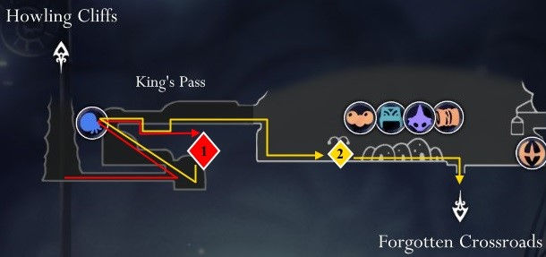

**Stage 2 - Forgotten Crossroads:**

1. Optional: meeting with Quirrel at the Black Egg Temple

2. Buy a map from Cornifer [for 30 geo]

3. Dig up Grub [1/46] in the acid room

4. Take the Aspid Hunter gauntlets

5. Open the stag beetle at the Forgotten Crossroads station [for 50 geo].

6. Collect the Grub [2/46] behind the destructible wall - (Optional: encounter Mila in the mine) - Collect 2 maggots [4/46] (behind the Husk Guard)

7. Boss Gruz Mother [1/17] - talk to Sly in the hut

8. Boss False Knight [2/17], get City Crest and Geo Chest - Ancestral Mound - Vengeful Spirit Spell [1/6] and Soul Catcher enchant [2/40 ] after Elder Baldur's mini-boss

9. Visit Grubfather for Geo

10. Return to Dirtmouth and buy Wayward Compass [3/40], Quill and Bench Pins [for 440 geo] from Iselda's store.

11. Defeat Elder Baldur to enter Greenpath.

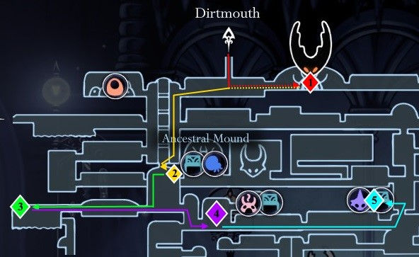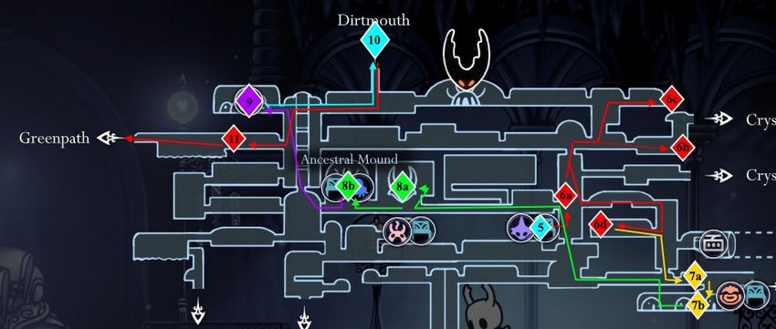

**Stage 3 - Greenpath:**

1. Buy a map from Cornifer [for 60 geo]; take the Grub [5/46] by clicking on the hidden platform

2. (optional: Hunter's journal); Grub [6/46] in the room next to the Hunter

3. Bench [for 50 geo]

4. Mini-boss Moss Knight

5. Protect Zote from Vengefly King

(Alternative path: don't defend Zote and get the Neglect achievement by returning to any point after obtaining the Mantis Claw and Zote's head. Note that if you do not defend Zote, the additional boss Gray Prince Zote will be blocked for you)

6. Grub [7/46] guarded by Moss Knight

7. Open the Greenpath Stag Beetle [for 140 geo], sit on the bench - take the Wanderer's Journal relic behind the destructible wall from the flower trap - Hornet Boss [3/17] - Mothwing Cloak Ability [1/9]

8. (Optional: head left to Lake Unn to meet Quirrel at the building)

9. Return for the Thorns of Agony enchantment [4/40]

10. Go to Fog Canyon

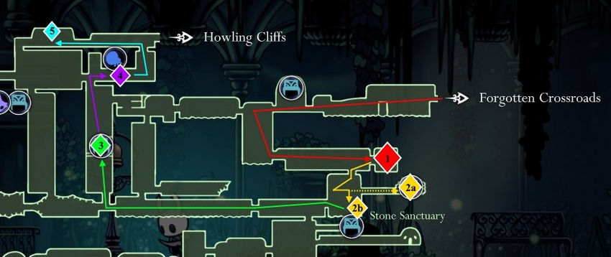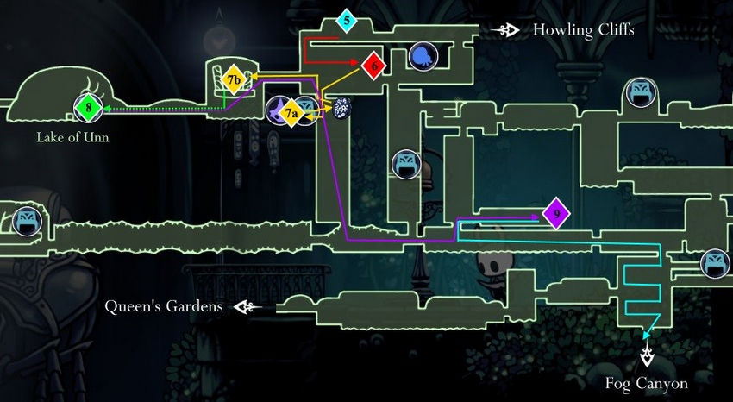

**Stage 4 - Misty Canyon:**

1. Walk straight through two rooms without exploring the side passages

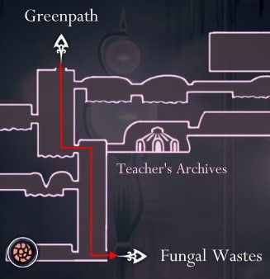

**Stage 5 - Fungal Wastes:**

1. Queen's Station (Quirrell encounter) - open the Queen's Station Stag Beetle Station [for 120 geo]

2. (Optional: Take the stag beetle to Dirmouth to face Zote if you defended him in Greenpath)

3. Buy a map from Cornifer [for 75 geo]

4. Relic Hallownest Seal - Two Shrumal Ogre mini-bosses for enchant [1/8]

5. Encounter Cloth - Grub [8/46] in the Busy Mushroom Room - open shortcut

6. Bench in the lower right corner - Mantis Village - Mantis Claw Ability [2/9]

7. Pick up the Wanderer's Journal relic in the room above the Mantis Village after climbing the vertical shaft by jumping off the wall - choose the correct path and use the City Crest on the statue

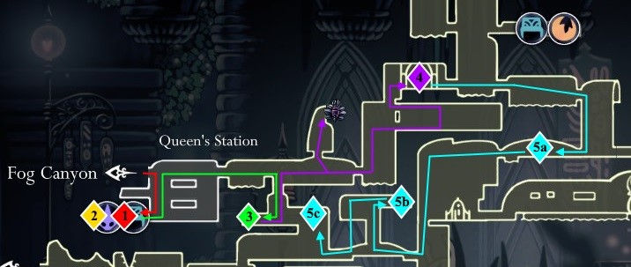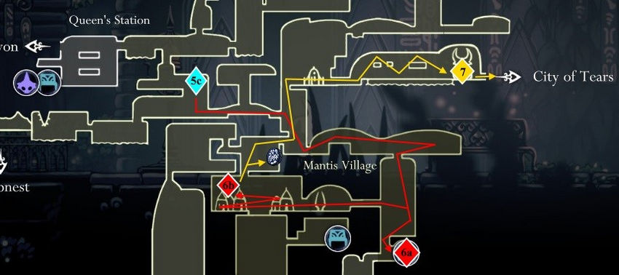

**Stage 6 - City of Tears:**

1. Bench (Quirrel meeting)

2. Nailsmith to improve Sharpened Nail [for 250 geo, 1/4]

3. Collect the Hallownest Seal relic on the scaffolding - Visiting the Lemm relic will give a geo

4. Grub [9/46] guarded by Winged Sentry - Bench [150 geo] and buy a map from Cornifer [90 geo]

5. Go left to the city pantries (if Zote is saved in Greenpath: meeting with him) - open the shortcut - pick up the Wanderer's Journal relic - open the city pantry [200 geo] - take the stag beetle to Dirmouth

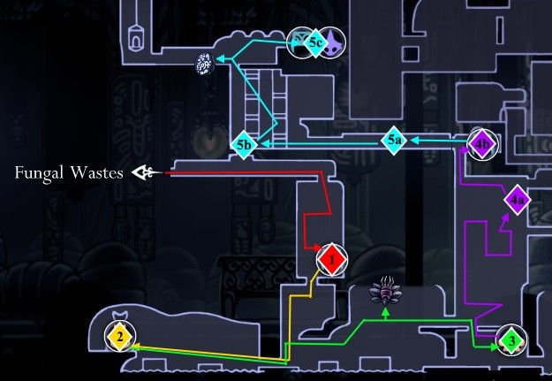

**Stage 7 - Forgotten Intersections:**

1. Buy Shard of the Mask [150 geo, 1/16], Gathering Swarm enchant [300 geo, 5/40] from Sly; (Optional: meeting with Tiso near the well)

2. After going down into the well, take the Hallownest Seal relic from the wall by jumping up the well - the larva [10/46] in the middle passage

3. Visit Grubfather for geo, Mask Shard [2/16], Grubsong char [6/40]

4. Use the jump from the wall to get to the boss Brooding Mawlek [4/17] - rewards with a fragment of the mask [3/16]

5. Get a Mask Shard [4/16, +1 HP] from Goam's Challenge under the Hot Springs Room.

6. (Optional: New Myla Dialogue) - Take the stag beetle to the city storerooms (meeting with Tiso if Tiso was spoken to in Dirtmouth)

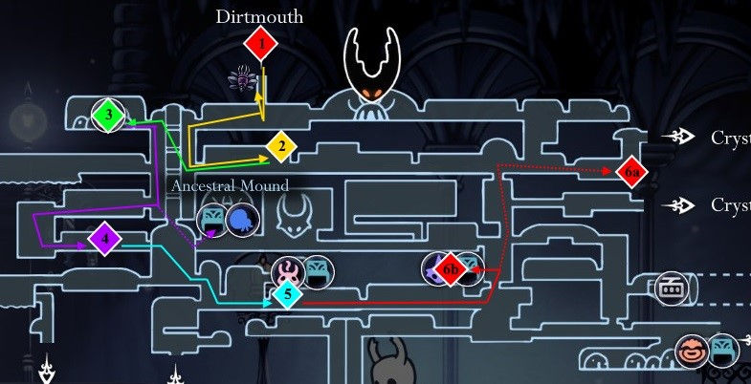

**Stage 8 - City of Tears:**

1. Enter Soul Sanctum after the Soul Twister mini-boss

2. Open the shortcut through the hole in the wall - Soul Warrior mini-boss at the top of the first room

3. Collect Spell Twister [7/40] from the top of the area - Boss Soul Master [5/17] for the spell Desolate Dive [2/6]

4. Collect the Geo Chest, Hallownest Seal Relic and Grub [11/46] on the way out of the Soul Sanctuary.

5. Take the stag beetle to Dirtmouth

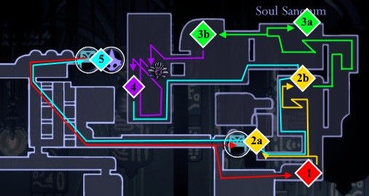

**Stage 9 - Forgotten Crossroads:**

1. Buy Lumafly Lantern [1800 geo] from Sly

2. Take the Stag Beetle to the Crossroads - Buy the Dive Charm [120 geo, 2/8] from Salubra

3. (Optional: New dialogue with Myla) - Use the dive spell on the dilapidated floor

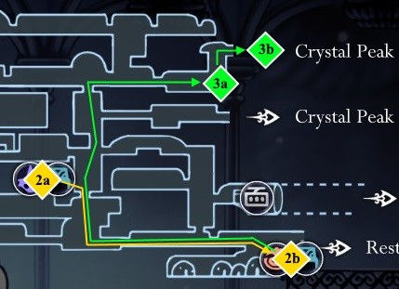

**Stage 10 - Crystal Peak:**

1. (Optional: enter the dark room and pay the gate fee [50 geo] back to the Crossroads) - Visit the bench on the lower right

2. Climb up the left vertical passage - Grub [12/46] at the beginning of the conveyor.

3. Buy a card from Cornifer [112 geo]

4. Boss Crystal Guardian, gives a bench

5. Return to the previous room - find the key of the seller

6. Climb further (encounter with Quirrel), go right, then jump down - collect the Wanderer's Journal relic - Crystal Heart ability [3/9]

7. Collect 2 Larvae [14/46] (Crystal Heart room, center crusher room)

8. Chara Deep Focus [8/40] after laser trap

9. Grub [15/46] on the shortcut to Dirtmouth (behind the mimicry and destructible wall) - unlock the elevator back to Dirtmouth

10. Return to the bench and go through the crusher room to get the Grub [16/46]

11. Go through the dark room in the lower right corner and jump into the large hole

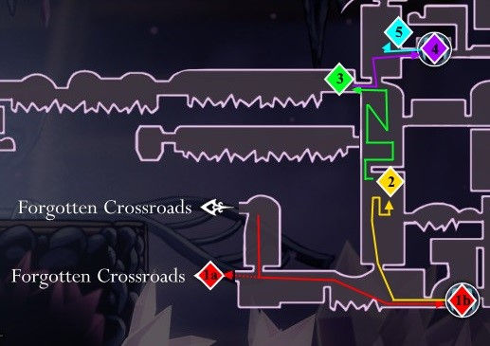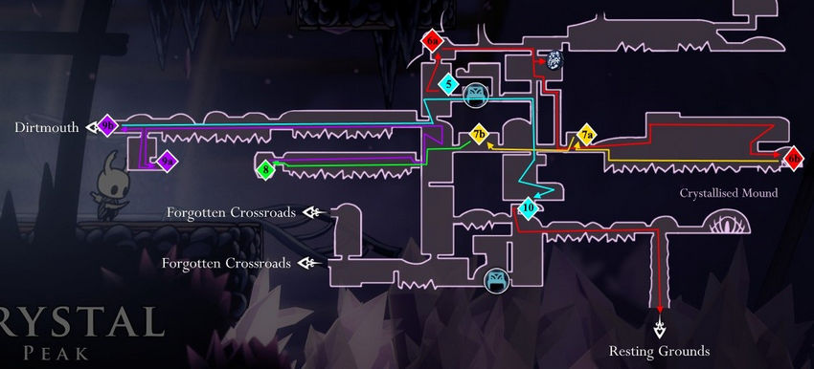

**Passing stages 11-20**

**Stage 11 - Resting Grounds:**

1. Get the Dream Nail ability [4/9]

2. Whispering Root for 20 entities [20/2400]

3. Take the Dreamshield Hairpin [9/40] behind the fake wall.

4. Press the lever to unlock the Rest Station.

5. Take the stag beetle to the city pantries

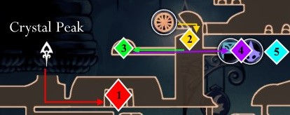

**Stage 12 - City of Tears:**

1. Whispering root for 28 entities [48/2400]; get a simple key

2. Visiting the relic of the seeker Lemma for geo

3. Fall into the well - use a simple key

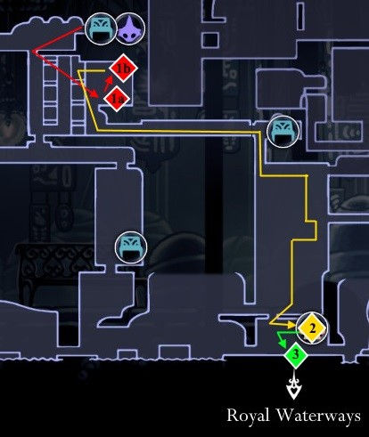

**Stage 13 - Royal Waterways:**

1. (Optional: smash the wall to find Tuk for Rancid Eggs)

2. Use the dive spell on the crumbling floor - sit on the bench

3. Walk up and left - buy a card from Cornifer [75 geo] after the Hwurmp glove and open the shortcards in Fungal Wastes

4. A short trip to the Fungal Wastes for the Dashmaster enchant [10/40], rescue Bretta after jumping behind a fake wall

5. Drop into the water and walk all the way to the left - Mask Shard [5/16]

6. Collect the Grub [17/46] in the hidden niche

7. Walk right - Dung Defender boss [6/17] gives the enchant Crest Defender [11/40] - hit the pump switch - Use the dive spell under the pump switch to access the secret room with the King's Idol relic - open the shortcut in broken elevator shaft

8. Back out and go right - Super Dash - pick up Isma's Tears [5/9] after Sentry Gloves

9. Collect the Grub [18/46] after Isma - quickly go past the Eternal Emilitia

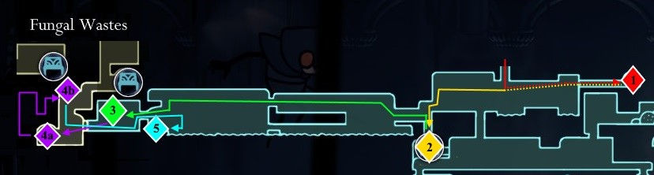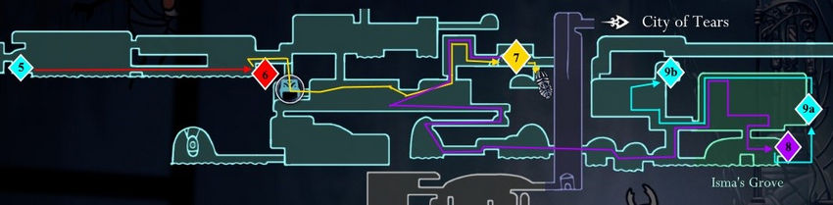

**Stage 14 - City of Tears:**

1. Open the shortcut on the left side of the city; cutscene with a fountain, meeting with Hornet

2. Go right - Gorgeous Husk for 420 geo in a building with several husk enemies (behind a fake wall, which is just above the ground on the right) - King's Station Stag Beetle [300 geo], sit on the bench

3. Collect the larva [19/46] under the protection of the Great Husk Sentry in the building (exit and load after freeing the larva so as not to kill the sentry)

4. Take the stag beetle to King's Station

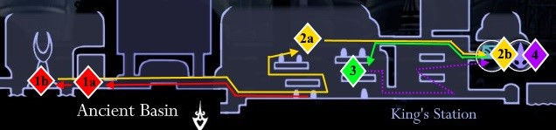

**Stage 15 - Fungal waste:**

1. Collect Mask Shard [6/16] after Wall Jumping

2. Collect the Wanderer's Journal relic - head down left to find the larva [20/46] and the Spore Shroom enchant [12/40] after the mushroom trial

3. Optional: meeting with the Moss Prophet (Moss Prophet)

4. Go to Deepnest for a short while, pick up the Grub [21/46] from the mimic room behind the destructible wall

5. Unlock the rest of the mantis village by clicking on the lever - bench in the lower right corner

6. Boss Mantis Lords [7/17] - Sign of Pride Pendant [13/40], Hallownest Seal Relic, Geo Chest and Bench in an Unlocked Room

7. Log into Deepnest

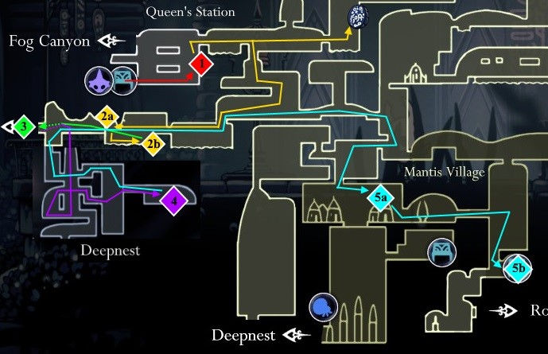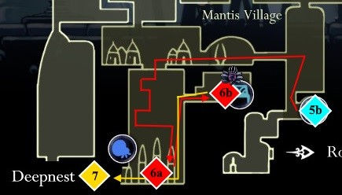

**Characters.HTML**

**The Knight**

The Knight is the protagonist and playable character of Hollow Knight.

The Knight is a discarded Vessel. They are the child of the Pale King and the White Lady, born in the Abyss with Void inside their shell. Hornet is the Knight's sister through their shared father. Like the rest of their Vessel siblings, the Knight is genderless.

After climbing out of their birthplace in the Abyss, the Knight witnessed their sibling, the Hollow Knight, being taken out of the Abyss by the Pale King. The entrance to the Abyss was sealed, causing the Knight to fall back down. Sometime after this, despite the entrance being sealed, the Knight and some of their siblings managed to escape the Abyss.

Eventually, the Knight ended up wandering outside of Hallownest for unknown reasons. Spending time in this area caused the Knight to lose their memories, but being there did give them a certain resilience. They returned to Hallownest after a call went out from either the Radiance or the Hollow Knight.

**Merchants**

NPCs who provide services and goods to the Knight in exchange for Geo.

|  |  |  |
| --- | --- | --- |
| Character | Description | Location |
|  | Sly is a Merchant in Hollow Knight. He sells many wares at his shop in Dirtmouth for Geo but drives a hard bargain. Sly also appears as a boss as the Godmaster Great Nailsage Sly. | Sly first appears in an abandoned house in the southeast region of the Forgotten Crossroads. After listening to him, he can next be found in Dirtmouth. |
|  | Iselda is a Merchant in Hollow Knight. She sells maps and mapping tools at her shop in Dirtmouth. | Iselda's shop is located in Dirtmouth, east of the Stag Station. |
|  | Salubra is a slug Merchant in Hollow Knight. She collects and sells Charms as well as Charm Notches. | Salubra's shop is located at the bottom of the Forgotten Crossroads. It can be accessed with the Mothwing Cloak or Mantis Claw, by Nail-bouncing on the Shade, or from the Blue Lake. |
|  | The Last Stag is an NPC in Hollow Knight serving as transport across Hallownest. | The Last Stag can be found in stations. |
|  | The Nailsmith is a Merchant in Hollow Knight. He provides a service to strengthen the Knight's Nail for Geo and Pale Ore. He provides the first Nail refinement for Geo only, after which he requires Pale Ore and Geo to upgrade further (see Nail for prices). | The Nailsmith is initially located in the west part of the City of Tears. Later on, he moves to Sheo's hut in Greenpath if he is spared. |

**Wanderers**

NPCs that are encountered in several locations and wander around Hallownest.

|  |  |  |
| --- | --- | --- |
| Character | Description | Location |
|  | Cornifer is an NPC in Hollow Knight. He is a cartographer and is working on mapping the entirety of Hallownest. | Cornifer can be found in nearly every area, selling his maps. He permanently moves to Dirtmouth after every map is bought or once all maps are available in Iselda's shop. |
|  | Quirrel is an inquisitive, up-beat explorer, fascinated by the myths of Hallownest for reasons he cannot explain. While he remains a simple observer, he is wise of the land's dangers and has some skill with a nail. | Quirrel can be found in several locations across Hallownest. However, he does not appear in all of them after he is encountered in Fog Canyon. |
|  | Hornet is the mysterious princess-protector of Hallownest’s ruins, a major character in Hollow Knight and the protagonist of Hollow Knight: Silksong. She wields a needle and thread with deadly prowess. As a boss, Hornet appears in two forms, Hornet Protector in Greenpath and Hornet Sentinel in Kingdom's Edge, which both have to be beaten to unlock her Hunter's Journal entry, or she can be defeated twice in Godmaster Godhome. | Hornet can be found in several locations across Hallownest. However, she may not appear in some due to events within the game. |
|  | Zote the Mighty is an NPC in Hollow Knight. | Zote can be found in several locations across Hallownest after he is saved in Greenpath. |
|  | Cloth is a wanderer in Hollow Knight. She is on a quest of her own throughout Hallownest to prove her bravery. | Cloth can be found in several locations across Hallownest. If she is encountered in the Queen's Gardens, she cannot be found in Dirtmouth and vice versa. |

**Nailmasters**

Legendary masters of Nail Arts who are willing to pass their knowledge to new pupils.

|  |  |  |
| --- | --- | --- |
| Character | Description | Location |
|  | Nailmaster Mato is one of three Nailmasters in Hollow Knight. He teaches the Cyclone Slash to whoever is willing to become his disciple. Mato also appears as a boss in the Godmaster Brothers Oro & Mato dual fight. | Nailmaster Mato is found in the Howling Cliffs. |
|  | Nailmaster Oro is one of three Nailmasters in Hollow Knight. He teaches the Dash Slash Nail Art to those willing to pay him for his services. Oro also appears as a boss as part of the Godmaster Brothers Oro & Mato dual fight. | Nailmaster Oro is found in Kingdom's Edge. |
|  | Nailmaster Sheo is one of three Nailmasters in Hollow Knight. Although retired, he teaches the Great Slash Nail Art to those seeking him. Sheo also appears as a boss as Godmaster Paintmaster Sheo. | Nailmaster Sheo is found in Greenpath, at the end of a spike-filled tunnel. Either Crystal Heart or Monarch Wings are required to reach him. |

**Others**

|  |  |  |
| --- | --- | --- |
| Character | Description | Location |
|  | Elderbug is an NPC in Hollow Knight. He is the oldest resident of Dirtmouth and a friendly face for new travellers seeking the Kingdom. He gives advice to anyone who passes by him. | Elderbug is located in Dirtmouth, next to the Bench. |
|  | The Grubfather is an NPC in Hollow Knight. He is an elderly Grub who bemoans the loss of his children. | The Grubfather is found in the northwest corner of the Forgotten Crossroads in a room full of small Grub dens; this room is referred to as the "Grubhome" in an official map. |
|  | Willoh is an NPC in Hollow Knight. She eats fungus in a broken-down Stag Station in Queen's Station. | Willoh is located in Queen's Station above the functional Stag Station. |
|  | Snail Shaman is an NPC in Hollow Knight. He gives the Vengeful Spirit Spell to the Knight in the Ancestral Mound. | Snail Shaman is found in the Ancestral Mound in the Forgotten Crossroads. He can be accessed after defeating False Knight or breaking the wall on the left side of False Knight's boss room. |
|  | Myla is an NPC in Hollow Knight. She is a happy little miner mining for treasure near the entrance to Crystal Peak. | Myla can be encountered in the northeast part of the Forgotten Crossroads, near one of the entrances to Crystal Peak. |

**Bosses.HTML**

**Bosses**

Bosses are unique enemies in Hollow Knight with typically higher health or deal more damage than the standard creatures in the same area. The Knight may have to defeat a Boss to access a new area, acquire an item, complete a quest, or simply further the main story of the game.

When the Knight encounters a Boss, their name will usually appear on-screen, and the music will change into a battle theme. There is a total of 47 bosses in the game.

|  |  |  |
| --- | --- | --- |
| Character | Description | Location |
|  | The Broken Vessel is one of the main bosses in Hollow Knight. It blocks the way to the Monarch Wings. The Lost Kin is its dream variant. | Broken Vessel can be found near the far west corner of the Ancient Basin, guarding the Monarch Wings Ability. |
|  | The Brooding Mawlek is a hidden boss in Hollow Knight as well as a Colosseum of Fools mini-boss. | The Brooding Mawlek in the Forgotten Crossroads is found beyond a wall jump section in a blocked room to the left of the vertical shaft filled with Gruzzers and Tiktiks.  It is possible to reach by Nail-bouncing on the spikes, although it is recommended to have obtained the Mantis Claw instead.  Another Brooding Mawlek can be fought in the Colosseum of Fools as part of the Trial of the Fool. |
|  | The Collector is a hidden boss in Hollow Knight. Defeating it grants the Collector's Map. | The Collector is locked in the Tower of Love, which can only be accessed using the Love Key, found in the Queen's Gardens. The Tower can only be entered from the deep lift shaft between Kingdom's Edge and the City of Tears. An exit to King's Station can be accessed after flipping a switch. |
|  | The Crystal Guardian is an optional boss in Hollow Knight. The Enraged Guardian is its second, stronger and faster form. Both forms have to be beaten to unlock its Journal entry. | The Crystal Guardian can be encountered for the first time in the Bench room in the centre of Crystal Peak. |
|  | The Dung Defender is one of the main bosses in Hollow Knight. This champion of the past defends the access to Isma's Grove. The Hidden Dreams White Defender is his dream variant. | Dung Defender is located in the east part of the Royal Waterways. |
|  | False Knight is one of the main bosses in Hollow Knight. He keeps the City Crest required to open the gates to the City of Tears. Failed Champion is his faster and stronger dream form. | False Knight is located in the centre of the Forgotten Crossroads. |
|  | The Mantis Lords are an optional boss in Hollow Knight. Defeating them grants safe passage through the Mantis Village. The Godmaster Sisters of Battle is their stronger form. | The area that the Mantis Lords are located in can be accessed after obtaining the Mantis Claw and activating a lever in the northwest part of the Mantis Village. |
|  | Gruz mother is an optional mini-boss in Hollow Knight. She is also a dual Colosseum of Fools boss. Unlocking her Journal entry requires beating 3 Gruz Mothers. | Gruz Mother can be found in the Forgotten Crossroads, sleeping peacefully until disturbed. |
|  | Soul Master is a main boss in Hollow Knight. Defeating him grants the Desolate Dive Spell. The Soul Tyrant is his dream variant. | Soul Master is located in the upper part of Soul Sanctum. |
|  | The Watcher Knights are a single main boss in Hollow Knight. They guard Lurien the Watcher, one of the three Dreamers. Their Journal entry is unlocked at the end of the fight, regardless of how many there were. | The Watcher Knights are located near the top of Watcher's Spire. |

**Warrior Dreams**

Lingering memories of particularly strong bugs, Warrior Dreams are a unique form of Boss in that the Knight can only challenge them once they have acquired the Dream Nail. Defeating a Warrior Dream rewards a large amount of Essence.

After acquiring the Dream Nail, the Knight may purchase the Warrior's Grave Pin from Iselda for 180, which reveals the location of the Warrior Dream in the area after that area's Map has been purchased.

Dream Nailing a Warrior Dream will automatically enter the fight, and Dream Nailing them after winning the fight will automatically collect the essence without dialogue. The Dream Nail has no effect when used during the fight.

|  |  |  |
| --- | --- | --- |
| Character | Description | Location |
|  | Elder Hu was a travelling sage who sought to purify the borderlands of Hallownest from the Infection. He reached the Mantis Village, but his own Infected mind made him see the Mantis Lords and the Tribe as afflicted by the plague. The Mantises killed him after he attacked them. | Elder Hu is found in the eastern part of Fungal Wastes not too far away from the entrance to the Mantis Village and the City of Tears. |
|  | Galien was a brave and undefeated warrior who claimed to be the strongest in Hallownest and desired to prove his valour to the Pale King as a Knight. He travelled to Deepnest in order to test his strength, but eventually found death instead. His husk lies in a cave filled with unusually large glowing mushrooms and a Lifeblood Cocoon, below the Failed Tramway. | Galien's corpse can be found in the west part of Deepnest. |
|  | Gorb the Great Mind was a mystic creature with a distended brain who claimed to be all-knowing. They goaded others to revere their mind and ascend with them to a different plane of existence. Their remains were buried on a hill atop the Howling Cliffs, with a tombstone carved in their image. | Gorb's grave is located in the northeast part of the Howling Cliffs. |
|  | Markoth was the only moth to carry a weapon besides Thistlewind. He went to Kingdom's Edge to seclude himself and meditate, hoping to uncover a truth long forgotten. Markoth fought any who would threaten him, regardless of their reasons. He eventually died, his remains never to be found, in a lone cave of Kingdom's Edge. | In order to reach the location, the Shade Cloak is needed to bypass the Shade Gate before Markoth's room. |
|  | Marmu was the innocent-minded yet strong protector of the Queen's Gardens. The Queen promised to teach her how to fly upon her return to the verdant retreat. Marmu passed away before that day and a totem in her memory was placed upon her grave in the gardens' wilds. | Marmu is located in the Queen's Gardens, west of the Stag Station. |
|  | No Eyes was a warrior of Hallownest who fell to the Infection. She could not sleep knowing the dreams would infect her mind with the light. To protect herself and other bugs, she stripped out both their eyes and her own before succumbing. She was laid to rest in the Stone Sanctuary, a place in complete darkness, and a carved statue was placed upon her grave. | No Eyes can be found inside of the Stone Sanctuary, in Greenpath. |
|  | Xero was a warrior of Hallownest who believed that strength would always allow him a bright future. When his mind was infected, he hoped to fight against the plague with violence. Fueled by the same hope, he turned against the Pale King, for which he was executed. Xero was buried in the Resting Grounds, his tomb a reminder to any who would betray the King. | Xero can be found in the west part of the Resting Grounds. |

**Contacts.HTML**

Email: (input text field)

Subscribe for updates: (checkbox)

Rate our website design: radio buttons (rating 0-5)

Rate our website content: radio buttons (rating 0-5)

Leave a comment about the website and its content: (text area)

Submit: (submit button)

Reset: (reset button)